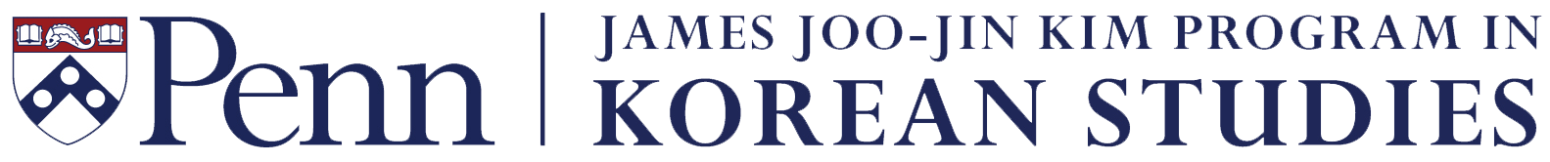
Faculty Research Grant Application
2019–20

In 2019, the James Joo-Jin Kim Program in Korean Studies will award up to two (2) grants, each in an amount up to $2,000, to assist a member of the University of Pennsylvania faculty to conduct research on Korea. All faculty members, including Korean language lecturers and other instructors of Korea-related courses, are eligible to apply. Awards will be made on the basis of the competitively established merit of the proposals. A track record of active contributions to the Kim Program will be taken into consideration. The grant recipient will be reimbursed upon submitting all relevant receipts after completing the research. Please e-mail a completed application form by 3:00 pm, Thursday, February 28, 2019 to Michelle Silverio <msilveri@sas.upenn.edu>. Award notifications will be e-mailed by mid-March.

A. Applicant information:

Name: Position:

Department: School:

Campus address:

E-mail: Telephone:

B. Title of the proposed research project:

C. Date/period of the proposed project:

D. Outcome of the project: will there be a new course or publication resulting from the research? What is it, and when is it expected to occur?

E. Proposal abstract (100 words maximum):

F. Budget (an application without this section completed will not be considered):

Item | Reason why needed | Date | Cost
TOTAL

