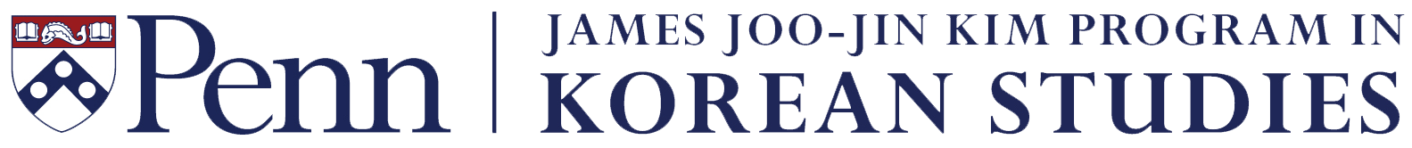
Language Lecturer Professional Development
Grant Application
2019–20

In 2019, the James Joo-Jin Kim Program in Korean Studies will award up to 3 grants, each in an amount up to $1,100, to assist Korean language lecturers at the University of Pennsylvania with the cost of attending a conference or other professional development opportunities related to their work. Awards will be made on the basis of the competitively established merit of the proposals. In order to be considered for a grant, please submit a completed application form. Grant recipients will be reimbursed upon submitting all relevant receipts after completing the travel. Please e-mail a completed application form by 3:00 pm, Thursday, February 28, 2019 to Michelle Silverio <msilveri@sas.upenn.edu>. Award notifications will be e-mailed by mid-March.

A. Applicant information:

Name: Position:

Department: School:

Campus address:

E-mail: Telephone:

B. Conference information:

Name:

Location:

Dates:

Name of panel/section:

Has your panel/paper been accepted?

Your role during the conference (indicate all that applies):

Panel chair/organizer:

Panel title:

Paper presenter:

Paper title:

Panel discussant/commentator:

Panel title:

Other role(s):

C. Budget (an application without this section completed will not be considered):

Item | Reason why needed | Date | Cost
TOTAL

D. Other funding sources, if any, and amount:

