Experiment #1 Mark A. Bruder

7-2-07 T.A. Michael Hall

Two-Base Extraction

Introduction:

The purpose of this laboratory experiment is to carry out a two-base extraction and separate the mixtures into three components. The lab will use a 2 gram sample of benzoic acid, 2-naphthol, and naphthalene which were previously prepared. Once separated out I will determine the relative amounts of the 2 acidic compounds and the neutral compound. This separation process will take place by extraction.

Procedure:

- Weigh your “unknown” sample of the mixtures and record weight
- Dissolve the sample in 30ml of diethyl ether
- Refer to pages 143-44 in the G&M book for general extraction procedure
- Transfer the ether solution to a 125-ml separatory funnel and add 20ml of 10% aqueous NaHCO₃
- Swirl funnel until all foaming has subsided (release CO₂ gas after inverting). Separate layers into two different beakers (transfer aqueous layer to a clean area).
- Repeat extraction of organic layer with another 20ml of 10% aqueous NaHCO₃. Separate the layers combining the aqueous layer with the first bicarbonate extract.
- Add 20% of cold 10% NaOH to the ether solution. Shake (don’t forget to vent) and separate layers into beakers.
- Transfer the separated ether solution to a 50-ml Erlenmeyer flask. Add .7g of anhydrous Na₂SO₄ to the solution. Cork and let stand.
- Add 3ml of HCl to each of the aqueous extracts dropwise until each solution is acidic to litmus paper. A precipitate should form as acid is added.
  - Cool the extract in an ice bath before and during the acidification step.
- Both solutions of acid should be in cool flasks in ice. Collect solids (separately) by vacuum filtration. Allow solids to air-dry until next week. Then obtain weights and melting points.
- Decant the diethyl ether solution away from the drying agent. Remove the solvent using rotary evaporator. Weigh flask, then scrape the solid and transfer to a vial (no cap) to air-dry until next week. Obtain the melting point.
- Calculate the percent recovery and the percent composition.

Table of Reagents:

Compound | Molecular  Weight  (amu) | pKa | M.P.  (⁰C) | B.P.  (⁰C) | Density  (g/cm³) | Flammability  Rating
Benzoic Acid | 122.12 | 4.17 | 122.4 | 249 | 1.08 | 2
2-Naphthol | 144.17 | 9.5 | 122 | 286 | 1.22 | 0
Naphthalene | 128.17 | Neutral | 80.6 | 218 | .997 | 2
Sodium Bicarbonate | 84.01 | 6.33 | 270 | 851 | 2.16 | 1
Hydroxide | 17.01 |  | 318 | 1390 | 2.1 | 0
Benzoate | 122.12 | 4.20 | 122.40 | 249 | 1.08 | 2
2-Naphthoxide
Hydrochloric Acid | 36.46 | -4 | 114.24 | 85.06 | .909 | 0

Flow Chart:

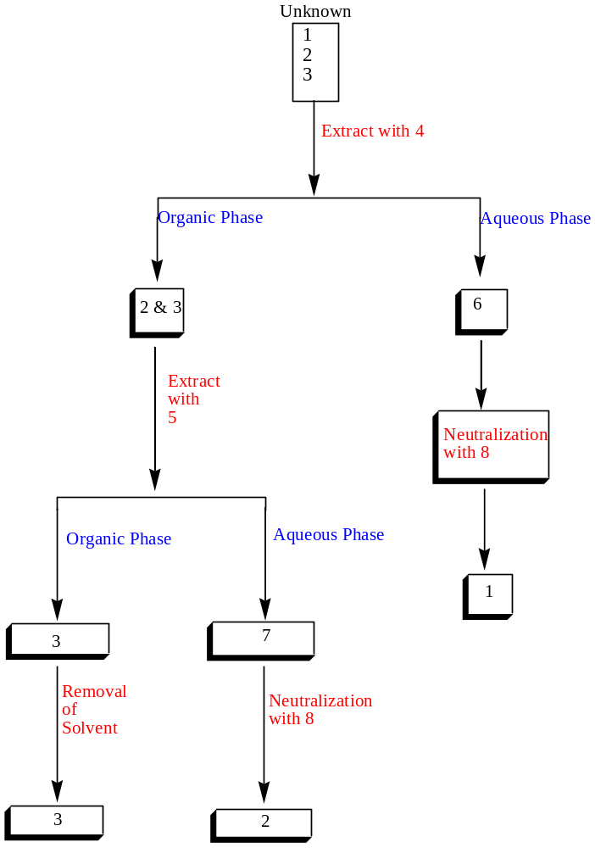

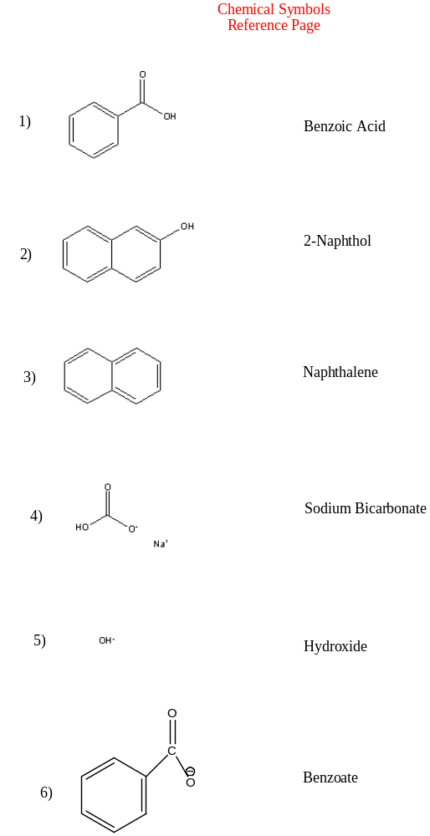
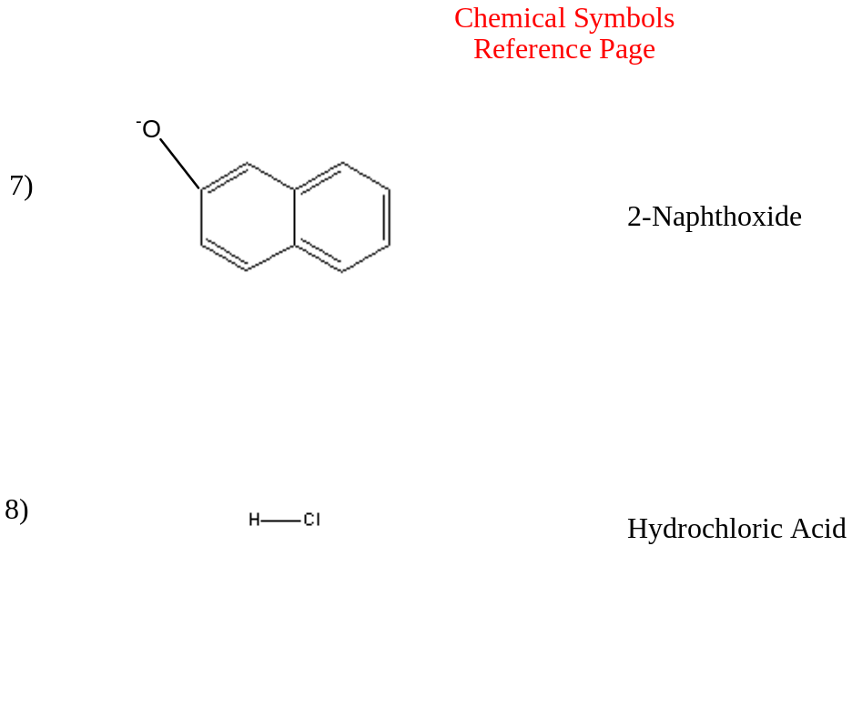
Observations:

Unknown sample #74 weighed 2.00 grams. The sample was then added to a beaker containing 30-mL of diethyl ether. The mixture dissolved and formed a solution that had a slight brown tint color. The ether was transferred to a 125-mL separatory funnel. Benzoic acid was extracted twice with a 10% aqueous sodium bicarbonate. While extracting the benzoic acid large amounts of carbon dioxide gas was vented out. The venting process take place by continuing to swirl the benzoic acid and venting until the carbon dioxide was released and a gas was generated. The aqueous portions were drained into the same Erlenmeyer flask. The extraction process was repeated with 2-naphthol using 20% of cold 10% NaOH. During this process the aqueous layer turned a slight brown tint color and the organic layer was clear. The aqueous layer was drained into a separate Erlenmeyer flask and a cork was placed in the flask. The extracts were placed in an ice bath. The separated ether solution was placed in a 50-mL Erlenmeyer flask and .7g of the drying agent anhydrous Na2SO4 was added to the flask. The flask was corked and left to stand. After that the anhydrous ether solution was decanted and placed in a 100-mL round bottom flask. The ether was then removed using a rotary evaporator. After drying the flask was re-massed and the mass of naphthalene was determined. The naphthalene was the scraped into a vial with no cap and left to stand and dry for a week before determining the melting point.
3 molar hydrochloric acid was being added drop wise to each of the aqueous extracts. As the acid was being added to the extracts there was fizzling which was the production of carbon dioxide as the precipitate was forming. After the solution became neutral a thick white solid precipitated and floated to the top. The solids were then collected via vacuum filtration and were placed on a watch glass to air-dry for next week.
3 molar hydrochloric acid was added dropwise into the flasks containing the sodium hydroxide and 2-naphtoxide which were removed from an ice bath. After the sodium hydroxide and 2-naphtoxide became neutral a tan and light brown precipitate formed. The solid were then collected via vacuum filtration and were placed on a watch glass to air-dry for next week.
The following week a piece of weighing paper was placed on electronic balance and tarred. The sample was then placed on the weighing paper and the mass was of the recovered substance was determined. A small sample of each of the substances was then placed in a separate melting-point capillary tube. The melting points of the substances were then determined.

Data:

Table: 1
Sample ID | #74
Mass of Vial with sample | 12.00g
Mass of Empty Vial | 10.00g
Mass of Sample | 2.00g
Mass of 100 mL round-bottom flask | 67.47g
Mass of 100 mL round-bottom flask and naphthalene | 68.27g

Table: 2
Substance | Mass Recovered (g) | Melting Point (⁰C) | Observations
Benzoic Acid | .23 | 120-122 | White Powder
2-naphthol | .41 | 119-121 | Light brown/tan powder
Naphthalene | .80 | 80-82 | Light brown/tan flakes

Results:

Percent Recovery:

Mass recovered (.41g + .23g + .80g)
------------------- x 100 ------------------------ x 100 = 72%
Original mass (2.00g)

Percent Composition:

Total mass recovered = (.23g + .41g + .80g) = 1.44g

Mass % of Benzoic Acid = .23g
------- x 100 = 11.5%
2.00g

Mass % of 2-naphthol = .41g
------- x 100 = 20.5%
2.00g

Mass % of Naphthalene = .80g
------- x 100 = 40%
2.00g

Discussion:

The purpose of this experiment was to determine the composition of an unknown mixture through the process of extraction. Once your unknown was complete extracted it should be identified by its physical properties which included the unknown’s acidic properties and the unknown’s solubility. All of the reactants were organic compounds. Two of the compounds were acids (one strong and one weak) and the other reactant was a neutral compound. All three reactants were originally extracted with sodium bicarbonate. The reactants 2-naphthol and naphthalene were part of the organic phase and they were each extracted with the strong base sodium hydroxide. The naphthalene was not affected by the base and after the removal of the solvent you should have been left with pure naphthalene. The 2-naphthol when combined with the hydroxide then formed a 2-naphthoxide which was neutralized with acid to form pure 2-naphthol. The benzoic acid after being extracted with the sodium bicarbonate became part of the aqueous phase to form benzoate. The benzoate was then neutralized with an acid to form benzoic acid. These steps should have allowed for the extraction and recovery of the unknown sample.
The overall percent recovery was 72%. The amount of substance that was lost during the laboratory experiment was due in part to the transferring of different solutions from their beakers into separatory funnels. There was spilling of some solutions which would cause for a lost of some the product. Also, during the filtering process some of the benzoic acid could have been mixed with the original organic layer before the aqueous layer was added then you would be left with the 2-naphthol mixing with the benzoic acid. In the last part of the filtration process the other organic layer would not be purely naphthalene but it could also have some 2-naphtol and benzoic acid. This could account for layers of solid mixed together in the drying process. Finally, there was residue left on the filter paper which could not be transferred to the weighing paper which could account for the lost of product.
There was seemed to be errors made in a lot of different steps of this process which included the transferring of material and the separation of different which would could account for the lost of products. The errors made is what accounted for the 72% recovery.

Post-Lab Questions:

#11) The lab starts with an aqueous bicarbonate because if you started with the strong base sodium hydroxide, the hydroxide would react with both the benzoic acid and the 2-naphthol. The aqueous bicarbonate will only react with the benzoic acid. The strong base would allow both the benzoic acid and the 2-naphthol to come out during the first extraction. Using a weaker base allows the benzoic acid to be removed in the first layer and the 2-naphthol to be removed in the organic phase.

#8)



